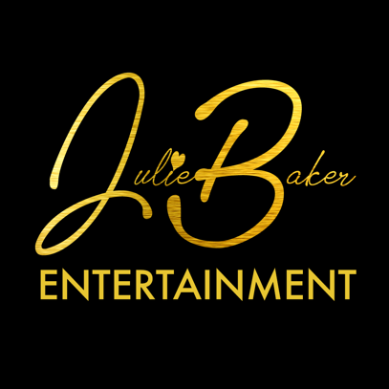
1524 Cuming St.
Omaha, NE 68102
800-246-0142
www.julie-baker.com

JULIE BAKER ENTERTAINMENT offers a variety of options when it comes to entertainment. Choose the option below that best fits your entertainment needs.

    - Julie Baker-Solo act
Piano and accompaniment tracks
    - Julie Baker Duo
With piano accompaniment
    - Julie Baker Trio
With piano plus sax OR drums
    - Julie Baker band Option #1
Julie with keys, drums, guitar
    - Julie Baker Band Option #2
Keys, drums, guitar, bass and optional sax
    - Julie Baker Band with horns-7 Piece Combo
    - Julie Baker with Full Orchestra
17 piece band

CLIENT REQUEST FORM

Thank you for your interest in Julie Baker Entertainment! In order to provide you with the very best service and product possible, we ask that you give us information and the details of your special event.

- Date of Performance:

- Time of Performance:

- Type of Venue: (Concert hall, theatre, business, private home, patio, etc.)

- Venue Address:

- Number of Musicians Required: (see options listed)

- Anticipated Crowd Size:

- Anticipated Crowd Makeup/Demographic:

- Genres or era of music conducive to this demographic:

- Length of Engagement:

- Setup/Tear down time:
(How much time prior to engagement and at the conclusion of engagement is available?)

- Description and dimensions of Performance Area: (Photos highly encouraged)

- Location of loading and unloading accessibility to performance area.

- Dates and times client is available for prior consultation and walk through of performance space:

- Is electricity readily available in the performance space?
(110, 220 or both?)

- Dress code for this event: (Casual, business casual, black tie, etc…)
How do you expect the band to dress?

- Please write a brief description of your event and your expectations of the entertainment. For example, is the music/entertainment to be more “background” while people mingle, is it a “show” where people are sitting quietly and listening or is it a “band” or “party” where people will be dancing and interactive with the band. This information helps us determine the equipment required for your event.

